*The Last Witch of Scotland*

Philip Paris, author of Waterstones’ Scottish Book of the Year 2024 - *The Last Witch of Scotland* - is to give a talk at Perth museum about the Scottish witchcraft trials of the 16th – 18th centuries, and the process of researching for and writing the novel. Tickets for the event are available via the museum’s website. Earlier that day Philip will be signing copies of his books at Waterstones in the St John’s Centre, Perth.

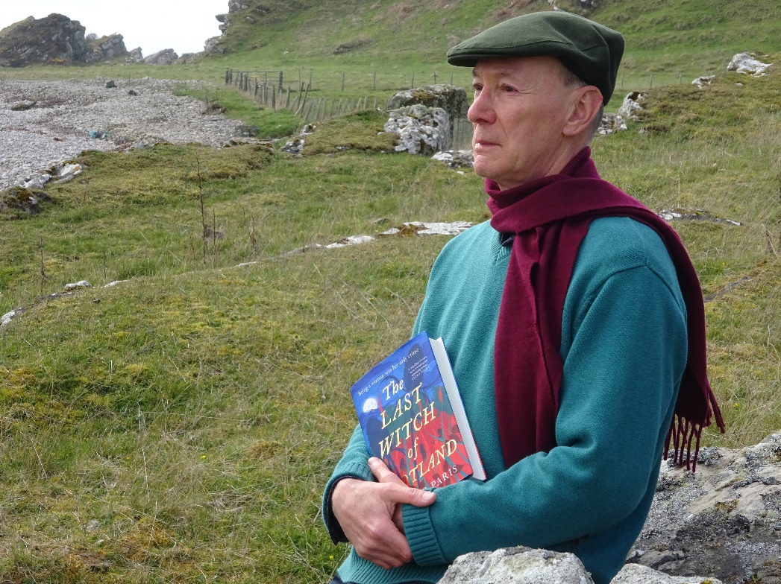

**Perth Waterstones: 11 am – noon, Thursday 5th June**

**Perth Museum: 7.30 – 8.30 pm, Thursday 5th June.**

Watch out for the historical fiction *A Fire in Their Hearts* – an epic story of love and a fight for freedom, set during the 17th century civil war between Scottish Covenanters and King Charles II of Scotland. To be published on 28th August 2025.